Architectural Control Committee

Request Form

Name: |  | Date Submitted :
Address: |  | Phone Number:

Type of work to be completed (Circle One)

Shed | Fence | Pool | Addition | Deck
Porch | Patio | Garage | Other(explain below)

Timeframe for Construction
Approximate Start Date :

Approximate Completion Date :

Detailed Description of Work

Please include details on dimensions, type of material to be used, your plot plan, the exact location of the change on your plot plan (to scale if possible) and any other pertinent information you want to include for the Architectural Control Committee. A contractor's diagram is also acceptable

Please submit this request form to:

Clairborne Architectural Control Committee
P.O. Box 549
Bear, DE 19701

If you mail your request, please do so via certified mail return receipt so that you have proof of delivery.

You may also choose to deliver this request form personally to one of the Architectural
Control Committee Members listed below.

Jeremy Keffer | 56 Eaton Place | (484) 769-3256
Mike Stone | 23 Pegasus Place | (302) 743-0897
Ed DeLooze | 5 Airdrie Drive | (302) 530-2950

Please make sure that the request form is dropped off in person (not just placed in a mailbox). This will ensure that your request is processed in a timely manner.

Plot Plan Example
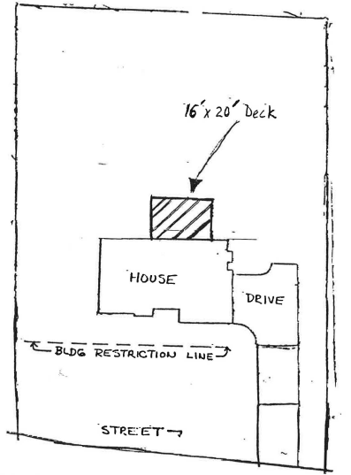

Project Information

16' W X 20' L pressure treated deck.

6" X 6" Pressure treated posts to rest on concrete footings
Deck framing to consist of 2" X 10" floor joists on 16" centers
Deck floor will be 5/4" X 6" pressure treated material

